Practical 2
Practical Title:
To understand version control concepts and perform basic source code management using Git
Theory:
1. What is Version Control System (VCS)?
A Version Control System (VCS) is a software tool that helps software developers manage changes to source code over time. It keeps track of every modification to the code in a special kind of database.
2. Types of Version Control Systems
(Centralized vs Distributed)
A. Centralized Version Control System (CVCS)
Concept: Uses a single central server that contains all the versioned files. Developers "check out" files from this central place.
Pro: Easier to manage and control access.
Con: Single point of failure; if the server goes down, nobody can collaborate or save versioned changes.
Example: Subversion (SVN), Perforce.
B. Distributed Version Control System (DVCS)
Concept: Every developer has a full copy (mirror) of the entire repository, including its full history, on their local machine.
Pro: Most operations are local and fast; allows offline work; no single point of failure.
Con: Initial cloning of a large project can be slower.
Example: Git, Mercurial.
3. What is Git?
Git is a free and open-source Distributed Version Control System designed to handle everything from small to very large projects with speed and efficiency.
- Created by Linus Torvalds in 2005 (the creator of Linux)
- It is the most widely used VCS in the world today
- It thinks about its data more like a series of snapshots of a miniature filesystem rather than a list of file changes
4. Key Git Terminologies:
Repository: A directory or storage space where your project files and the entire history of their changes are kept. It can be Local (on your computer) or Remote (on a server like GitHub).
Commit: A "snapshot" of your changes. When you commit, Git saves the current state of your files with a unique ID and a description message
Branch: A parallel version of a repository. It allows you to work on a new feature or fix a bug without affecting the "Main" or "Master" code
Merge: The process of taking the changes from one branch and integrating them into another (usually merging a feature branch back into the main branch)
Clone: The process of creating a local copy of a remote repository on your computer, including all files, branches, and history
Procedure:
Step 1: Install Git and verify installation
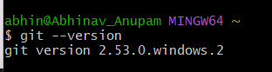
Step 2: Configure Git
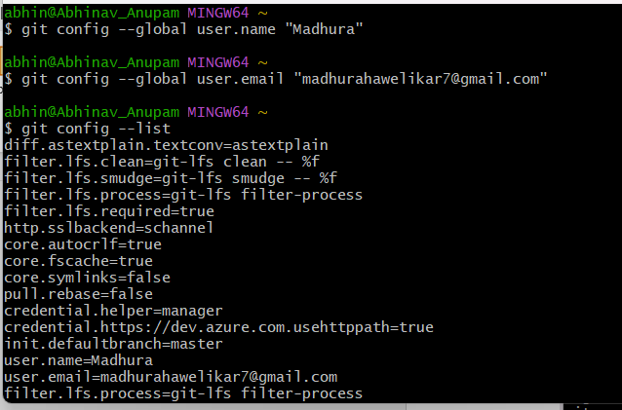
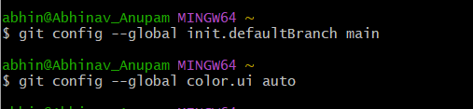
Step 3: Create a Repository
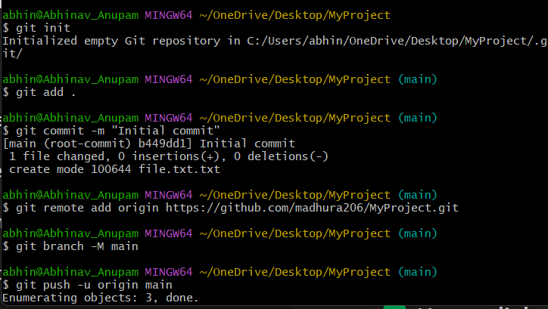
Step 4: Create a file and add content
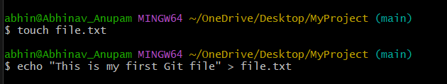
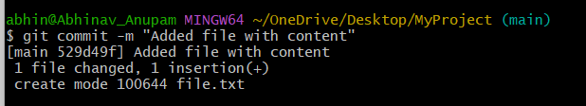
Step 5: Add and Commit
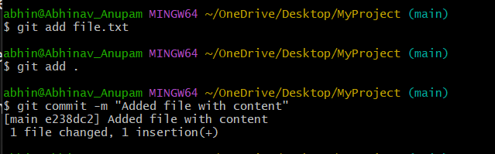
Step 6: Connect to GitHub and Push
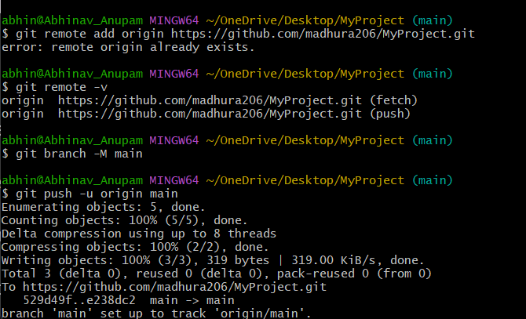
Step 7: Pull changes
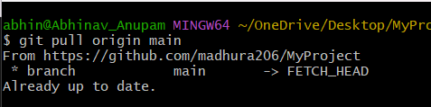
Activity / Task:
Task 1:
Create your own GitHub repository and push at least one file.
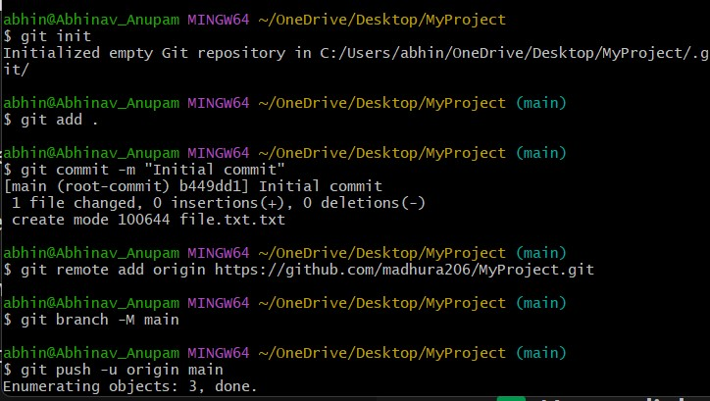
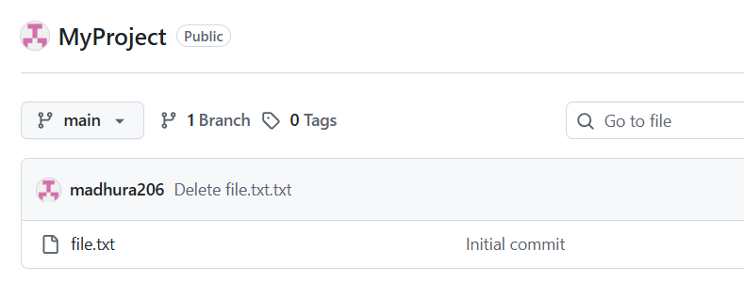
Repository Link:
https://github.com/madhura206/MyProject
Task 2:
Create a new branch and merge it with main branch.
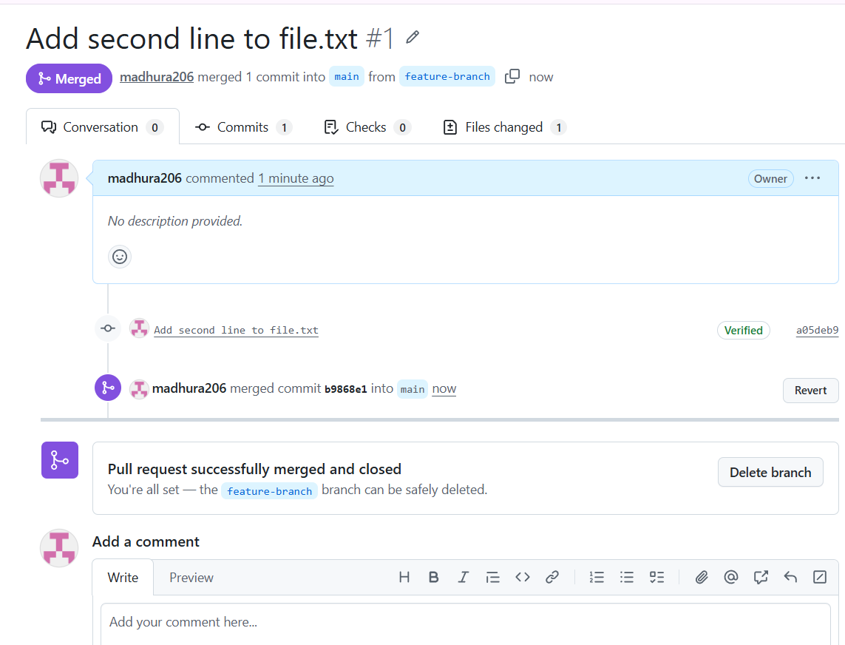
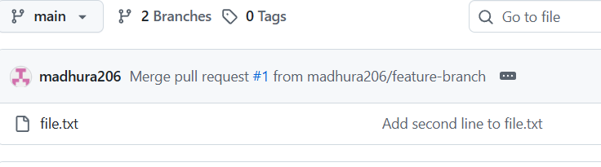
Commands Used:
git branch feature-branch
git checkout feature-branch
git add .
git commit -m "Changes in feature branch"
git checkout main
git merge feature-branch

Advantages of Git:
1. Distributed System: Every user has a full copy of the repository and its history locally, allowing for offline work and no single point of failure
2. Speed: Most operations (committing, branching, viewing history) are performed locally on the hard drive, making it much faster than centralized systems
3.Efficient Branching: Git makes it very easy to create, delete, and merge branches, allowing developers to work on features in isolation without affecting the main code
4. Data Integrity: Every file and commit is checksummed using SHA-1 hashing, ensuring the history is secure and cannot be altered without detection.
5. Staging Area: Git features an intermediate "Index" or staging area, which allows developers to review and format their changes before finalizing a commit
Challenges in Version Control:
1. Merge Conflicts: Occur when multiple developers modify the same line of code simultaneously. Resolving these requires manual intervention and deep understanding of the code changes.
2. Steep Learning Curve: Tools like Git have complex commands (e.g., rebase, cherry-pick) and concepts that can be difficult for beginners to master, leading to accidental errors.
3. Handling Binary Files: VCS is optimized for text/code. Storing large binary files (images, videos, PDFs) significantly slows down performance and increases repository size.
4. Security Risks: Accidentally committing sensitive data like API keys or passwords is a major risk, as the information remains stored in the version history indefinitely.
5. Repository Bloat: Without a proper cleanup strategy, repositories can become cluttered with hundreds of stale branches and unnecessary temporary files over time.
Conclusion
Version control concepts were successfully understood and implemented using Git.
Basic source code management operations like repository creation, adding files, committing changes, and branching were performed effectively.
This practical demonstrated how Git helps in tracking changes and managing code efficiently.

